Welcome!

Thanks for attending Monadnock Trout Unlimited’s Fly Tying Class. We hope you learn a lot about fly tying, learn a little bit about fishing the Monadnock Region, meet some fellow fishermen, and have a whole lot of fun in the process.
Why are we teaching these classes? All of the instructors and helpers in this class are volunteers. We’re spending our time teaching these classes for three main reasons.

1. We want to expose more people to the work that Trout Unlimited is doing. We think a good way to do that is to meet like-minded people, who might be interested in TU’s activities.
2. We want to raise some money for our TU Chapter. Over the past few years we have sponsored; stewardship of a local river, children’s fishing derbys, the Trout in the Classroom Program, and a variety of other projects. It takes money to do these things, and we think this is a fun way to generate some funds.
3. Most importantly, we like to tie flies! All of the instructors here are avid fly tiers (OK, some are obsessive-compulsive fly tiers...). We enjoy tying, and we enjoy tying in a group with other tiers. We enjoy teaching newcomers how to tie as well.

So who or what is Trout Unlimited? Well, it’s a national organization with local chapters. The overall mission of TU is to conserve, protect and restore North America’s trout and salmon fisheries and their watersheds. TU members believe that the best way to restore America’s trout water is to create healthy habitat, not necessarily by heavy stocking. Once streams are returned to their original status the fish will take care of themselves. In the Monadnock Region we assist Fish and Game with stream surveys, perform habitat restoration like removing dams and adding appropriate structure to create riffles and rapids, and work with landowners to provide stewardship services for trout streams. We meet monthly in Peterborough, where we usually have a guest speaker discussing a fishing trip, a guide service, or a TU program. You’re welcome to join us at any time.

So let’s tie some flies!

Tight lines,

Larry, Mike, Patrick & Lew,

We thought it might be good to set down a few ground rules that pertain to the class.

- We’ll meet Wednsday evenings starting January 10th. In the event of bad weather class will be cancelled. We’ll try to contact class participants if the class is cancelled so be sure we have your contact information (email, phone etc.).

- The class meets from 6:00 until 8:30. Please come early to set up your equipment so the class can start on time. We will plan to stay later for anyone who wants more practice or 1 on 1 instruction. We will take a 15 minute break sometime during the evening.

- In the event of snow days, we’ll make up the classes at the end of the session.

- Students are responsible for their own tools. We have some tools to borrow, and have some TU toolsets available to buy ($25.00). We can point you to some places to buy tools as well.

- Materials will be provided for students to use during the class, as well as for a bit of “homework.” You will need to provide your own materials for flies tied outside of class. We can give you guidance here as well.

- Have a fly you’d like to learn how to tie? Bring it in. We can work on it with you.

- We’ve published a list of patterns, but this will likely change based on the make-up of the class. Please be flexible. We will post patterns for the class on the Chapter web site (www.monadnocktu.org). There are pages dedicated to our tying classes and fly patterns.

- We’re all here to have fun! We hope that you learn something in the process, but your main goal is to enjoy yourself. If this isn’t happening, let us know! We probably just forgot to tell you something important...

The following patterns will be taught. We chose them because:

- They’re easy to tie.

- They catch fish! In the Ashuelot, not just in Montana.

- If you can tie these, you have the skills to tie just about anything.

- They follow the life cycle of the insects.
Date | Type | Patterns
Jan. 10 | Fundamentals | Walt’s Worm & Wooly Bugger
Jan. 17 | Nymphs | Pheasant Tail Nymph/Gold Ribbed Hairs Ear
Jan. 24 | Terrestrials | Hopper/Cricket/Ant
Jan. 31 | Dry Fly | Cahill/Parachute Adams
Feb. 7 | Streamers | Class Favorites
Feb. 14 | TBD | Class Favorite?

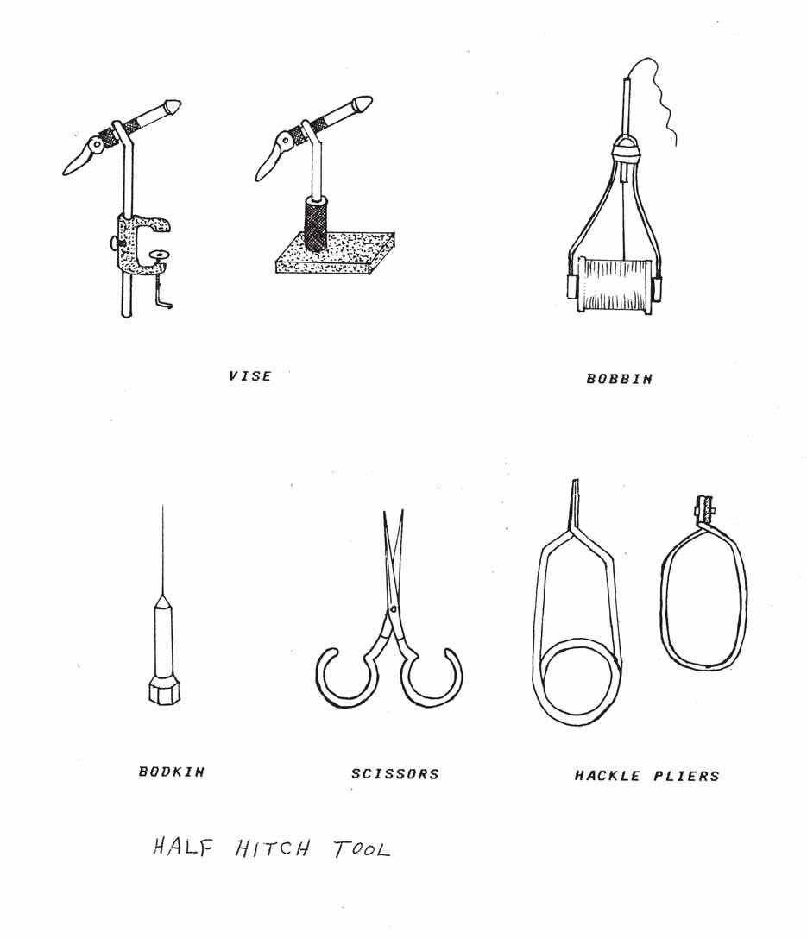

Vise Bobbin

Bodkin Scissors Hackle Pliers

Bend
Shank

Barb
Gap
Eye

Point

Hook sizes are designated numerically, the larger the number, the smaller the hook. A
#12 is an average size trout hook. A #14 is two sizes smaller. A #8 is four sizes larger. Odd hook sizes are available from some manufacturers, but they are rare.

Variations from the standard wire size and shank length are designated with an “X” system.
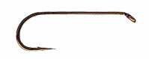
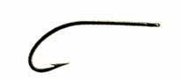
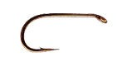
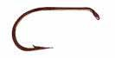
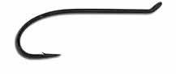
XL – Long Shank
Regular
XF Extra Fine Wire
RE - Ringed Eye
XST - Extra Stout Wire
XS - Short Shank
TUE -Turned Up Eye
TDE - Turned Down Eye
Regular Size Wire

If a number precedes the “X” it denotes the amount of variation. For example, compared to a standard #6 Hook:
A #6 2XL has a shank length of a #4 Regular hook.
A #6 4XL has a shank length of a #2 Regular hook.

Some good local sources for fly tying materials.
Sams Keene, Brattleboro Vt.
Stone River Outfitters Bedford, NH
Evening Sun Fly Shop Pepperell, MA
Frenchy’s Fly Shop Keene

Some good on-line sources for materials at a good price:
Hook and Hackle http://www.hookhack.com/
Fly Tying World http://www.flytyingworld.com/
J. S. Stockard http://www.jstockardflyfishing.com

Some nice websites:
Global Fly Fisher | http://globalflyfisher.com/ | Great Tutorial
Fly Fishing Network | http://www.flyfishingnetwork.com | Pattern Library
Fly Fishing Forum | http://www.flytyingforum.com | Patterns & Tutorials
Fly Anglers Online | http://www.flyanglersonline.com/ | Good general Information
MidCurrent | http://www.midcurrent.com | Tying, Fishing, Casting
CASF | www.ClassicAtlanticSalmonFlies.com | Larry’s Site

Some beginning books:
Basic Fly Tying Ed Kock and Norm Shires
Fly Tying Made Clear and Simple Skip Morris
The Fly Tyer’s Primer Dick Talleur
Orvis Guide to Beginning Fly Tying Leiser and Vincigurra

2 1

10 9
3
4

11

12
7
5

8 6

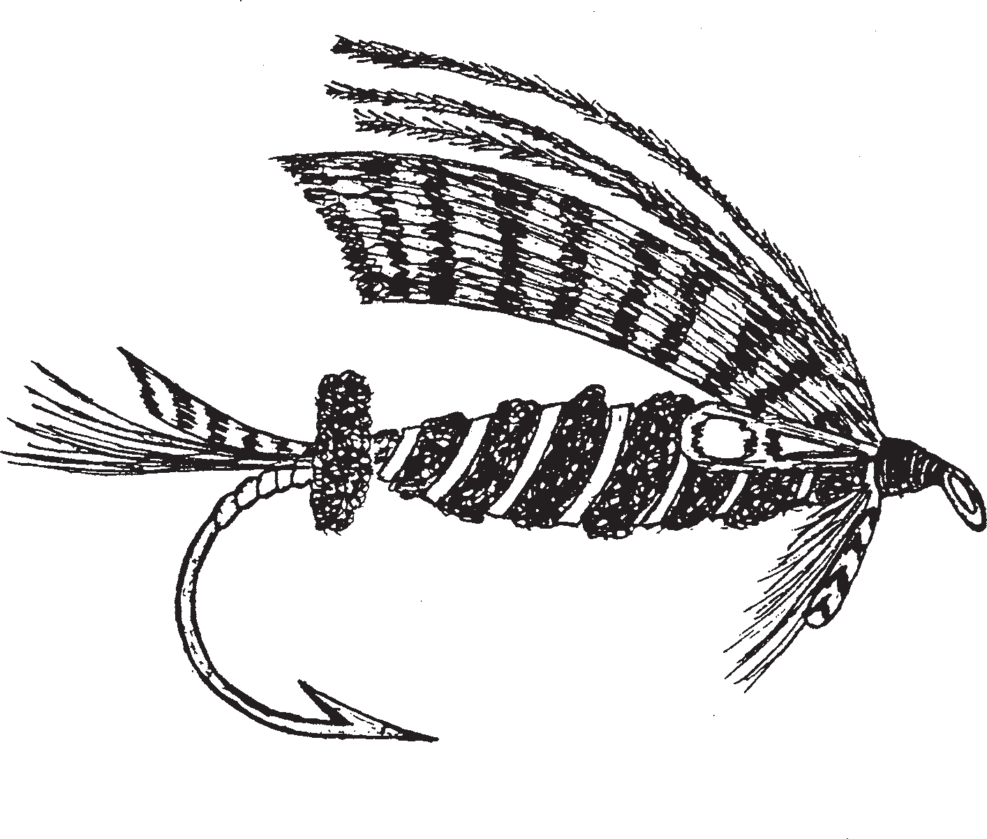
1. Topping
2. Wing
3. Shoulder
4. Head
5. Throat
6. Hackle
7. Ribbing
8. Body Proper
9. Butt
10. Tail Veiling
11. Tail
12. Tag

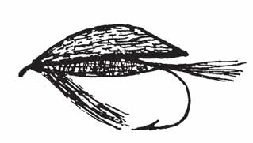
C

B
Wet Fly
A = 1/2 B
A B = 7/8 E
C = F
D = To Hook Point
EF

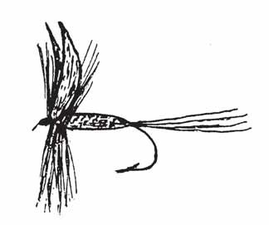

C D
A

BEF
Dry Fly
A = F
B = 7/8 E C = F
D = 3/4 C
Legend
A = Tail
B = Body
C = Wing
D = Hackle, throat or beard
E = Shank length
F = Hook length

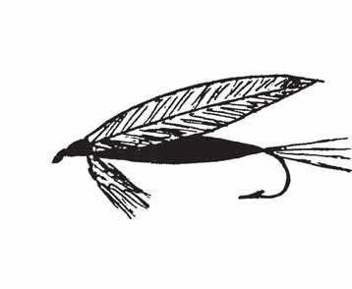

Streamer A = 1/2 B B = 3/4 E C = A + B
A D = 1/2 B
B
E
F

Since the mid-30’s the ought system (zeros) was used to rate or dimension fly tying thread. As an example, a thread with six zeros (000000) translated to a 6/0 thread. The higher the number of zeros the finer the thread.

As new manufacturers came into the market the system lost its effectiveness. Manufacturers used 6/0 for example but their thread diameters differed.

The new system being introduced is called denier (pronounced den yer). Denier is a commonly used measurement of thread employed in the garment industry. Denier is the weight in grams of 9,000 meters of thread. A thicker, heavier thread will have a correspondingly larger denier number.

As this new system is introduced you will see both systems being sold. The major manufacturers are adopting the denier system. There is nothing wrong with the old thread itself.

Here are some typical sizes of thread we will use in fly tying:

Brand Ought/denier

Gudbrod | 8/0 (67) | 6/0(143) | 3/0(176)
Uni | 8/0 (72) | 6/0 (135)
Wapsi UTC | NA (70) | NA (140) | NA (210)

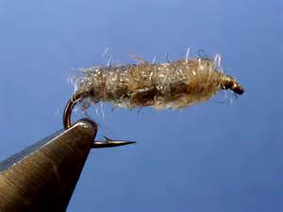
Walt’s Worm
Hook: Dai-ichi #1710, Size: 12
Thread: 6/0 or 3/0 tan
Weight: .020" lead wire for #8-10,.015" leadfree wire for #12-16, .010" lead wire for #18
Body: Hare's Ear Plus #1, tied cigar-shaped and picked out aggressively

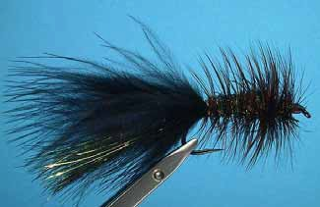
Wooly Bugger
Hook: Daiichi 1720 #10 (kit), Mustad 97580, or equivalent, size 2 to 8
Thread: Black, 6/0
Weight: Fine lead substitute
Tail: Black Marabou
Hackle: Black Saddle Hackle
Body: Olive Chenille
Head: Black Thread

Skills Learned
Starting and ending thread
Soft Pinch Loop method of tying on material
How to Dub material to thread
How to tie in hackle
Palmering hackle

Tying Instructions – Walt’s Worm
1. Place hook in vise and attach thread behind eye.
2. Wind to bend of hook using loose turns.
3. Dub Hares Ear Plus Material to Thread.
4. Wrap to just behind the eye forming a cigar shaped body.
5. Form a small head.
6. Whip Finish.
7. Tease out dubbing to add movement & sparkle in the water.

Variations
1. Jig style hook with bead head on hook.
2. Try different colors

Tying Instructions – Wooly Bugger
1. Place hook in vise and attach thread behind eye.
2. Wind to bend of hook using loose turns.
3. Tie in marabou. Trim excess and bind down butts.
4. Tie in hackle feather.
5. Tie in chenille.
6. Take thread forward to just behind eye.
7. Wrap chenille forward to approximately 1/16” behind eye. Tie down and trim excess.
8. Wrap the hackle feather forward by palmering or spacing the feather so it ends just behind the eye. Tie down and trim excess.
9. Build up a tapered head and finish with a whip finish or series of half hitches.

Variations
1. Start with bead head on hook.
2. Start with ten wraps of lead substitute wire on hook.
3. Add crystal flash to tail.
4. Replace marabou with wool yarn tail and use shorter hook for Wooly Worm

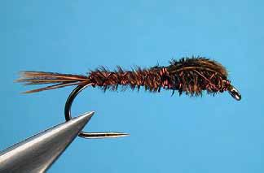
Pattern
Hook: Daiichi 1720 #10 (kit) or equivalent size
14-22
Thread: Black or Brown 6/0 (option - fine copper wire)
Rib: Fine copper wire
Tail: 3 or 4 strands - pheasant tail center herl
Body: Pheasant tail herl
Wing case: Pheasant tail herl

Skills Learned
Review:
Starting and ending thread
Soft Pinch Loop method of tying on material
Dubbing techniques
New Skills:
Ribbing techniques
Nymph proportions
Tying in abdomen and wingcase
Learn how to tie in tail, abdomen, thorax & wing case
Pheasant tail very delicate

Tying Instructions
1. Place hook in vise - tie in 3/16 behind eye - thread to rear of hook
2. Tie in tail - do not cut excess herl
3. Tie in fine copper wire rib - spiral thread to front
4. Slightly twist excess herl from tail - wind past center of hook
5. Counter wrap wire rib through abdomen - build up thorax with excess wire - tie off
6. Spiral thread to center of hook - tie in wing case (5 or 6 pheasant herls treated with head cement
7. Tie in 2-3 herls in front of wing case to build up thorax
8. Bring wing case over thorax and tie off
9. Build up slight head - tie off - head cement

Variations
1. Use peacock herl for thorax
2. Use flash for wing case
3. Use bead head or lead substitute
4. Try green and red dyed Pheasant Tail

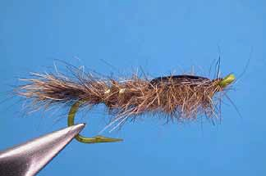
Pattern
Hook: D1720 #10 (kit) Thread: Black, 6/0
Weight: Fine lead substitute, or beadhead
Rib: Fine gold oval tinsel or mylar
Tail: Hare’s mask fibers
Abdomen: Hare’s mask dubbing
Wing case: Dark goose or turkey quill
Thorax: Hare’s mask

Tying Instructions
1. Place hook in vise and attach thread behind eye.
2. Wind to bend of hook using loose turns.
3. Wrap hook with ten turns of lead substitute.
4. Tie in a pinch of hare’s mask for the tail. Trim excess and bind down.
5. Tie on oval tinsel for ribbing.
6. Dub the thread with hare’s ear and wrap the dubbed thread forward to approximately the half way point of the hook shank. This is the abdomen. Taper the abdomen to make it smaller at the rear of the hook and wider/thicker at the front.
7. Spiral the rib forward with spacing between the wraps. Tie in just ahead of the abdomen.
7. Cut a 3/16” piece of wing quill. This can be cemented to prevent it from separating. Tie the quill in by the butt for the wing case.
8. Dub the thorax using hare’s mask. Build the thorax up to be larger than the front of the abdomen. Wrap the dubbing forward to within 1/16” of the eye of the hook.
9. Pull the quill forward and over the dubbed thorax. Tie off the quill and trim the excess.
10. Form a small head and finish with a whip finish or half hitches.

Variations
1. Omit the lead substitute.
2. Add a beadhead.
3. Use flash material for the wingcase.

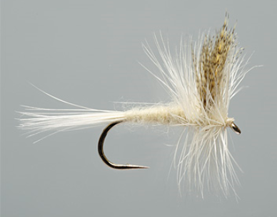
Cahill
Hook: D1180 #14
Thread: Cream 6/0
Body: Light cahill dubbing
Tail: Light ginger or cream hackle barbs
Wing: Woodduck flank - mallard flank
Hackle: Light ginger or cream dry fly hackle

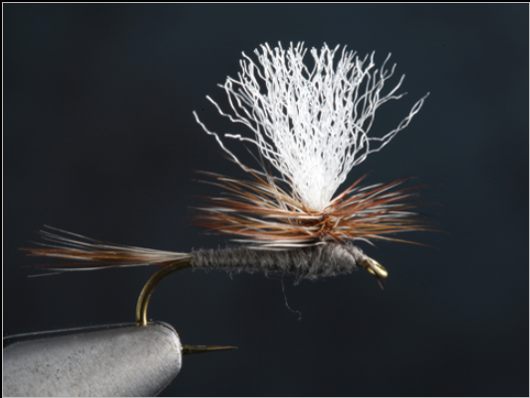
Parachute Adams

Hook: Daiichi 1180-14
Thread: Black or gray 6/0
Tail: Brown & Grizzly Hackle fibers
Body: Gray dubbing
Wing: White Calf Tail or Antron
Hackle: Brown and Grizzly, mixed

Skills Learned:

- Dry fly proportions
- Upright & Divided wings
- Winding Dry Fly Hackle
- Parachute Style Hackling

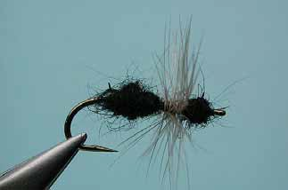
Week 5 Terrestrials
a) Ants
Hook D1180 #14 Thread 6/0 black
Body fine black dubbing Wing post - orange antron Hackle black

b) Beetles
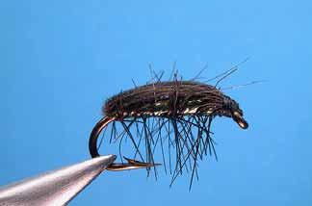
Hook D1180 #14 Thread 6/0 black Body peacock herl Shell orange foam Hackle black

c) Hopper
Hook D1280 #12 Thread 6/0 primrose Body yellow dubbing Wing turkey quill Hackle deer hair

d) Cricket
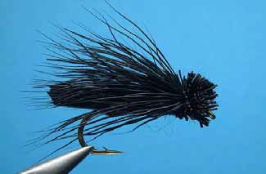
Hook D1280 #12 Thread 6/0 black
Body black dubbing Wing black goose quill Hackle black deer hair

